Making Sense of School Leadership

Facilitator Handbook

Introducing Making Sense of School Leadership (MSSL)

Making Sense of School Leadership (MSSL) is a leadership development programme for senior school leaders. It has been developed by a partnership of schools and academic institutions from across Europe as part of the Getting Heads Together (GHT) Erasmus project.

What makes MSSL different?
Leading a school is inherently difficult. School leaders are required to make sense of complex problems, often in conditions of uncertainty and flux.
MSSL aims to support school leaders in making sense of the complex problems they face by recognising this complexity, exploring it, and improving decision making. Unlike many leadership development programmes which take an overly theoretical approach, GHT draws on the participant’s context and the problems they face in their schools.
The programme employs a variety of methods to stimulate individual and collective sense-making, including salient case studies, personal reflection, and field work.

What do we mean by school leadership?
For the purposes of this programme, school leadership is defined as the process of influencing teams, individuals, and organisations through discharging leaders’ responsibilities, which include:
- Establishing a positive school culture and supportive environment;
- Organising and teaching the curriculum;
- Adopting effective approaches to professional learning and development;
- Attending to student behaviour and the relationships within the wider community; and
- Managing an efficient and effective organisation.

What makes an effective school leader?
The way leaders discharge their responsibilities and influence their schools depends on how they make sense of their role and the organisation they lead.
The GHT programme draws on research into the psychological concept of sensemaking. In relation to schools, sensemaking is concerned with how leaders understand and interpret their role, their context, and events, and how this determines the way they interact with their environment. School leaders must have sophisticated sensemaking capabilities to be effective.
The programme also draws on complexity theory. As we stated previously, schools are very complex organisations. Leaders are commonly confronted with ‘complex’ problems which are difficult (or even impossible) to define and resolve. How leaders cope with this complexity is central to their development as a leader. Collaboration with others is central to this capability.

How do school leaders develop?
How we make sense of the world changes throughout adult life, including how we respond to complex environments. Adult Ego Development (AED) theory provides a framework for understanding the stages of this development. The most advanced (Individualist) stage is associated with practices which, we assert, are beneficial for school leaders in coping with complexity. These practices include comprehending and feeling comfortable with complexity; valuing and seeking new perspectives on a problem; and taking the time to reflect and gain new insights into problems.
GHT employs these ideas to deliver an approach to leadership development which equips school leaders with ‘sensemaking tools’ which support them to independently and collectively make sense of the needs of their context to better deal with the complex and complex problems of school improvement.

Using this handbook
This handbook is written for Facilitators of the programme. MSSL has been designed so that schools, groups of schools, or leadership development institutions can deliver the programme independently. This handbook provides an overview of the programme, explains the roles of various individuals in delivery, and references the resources available.

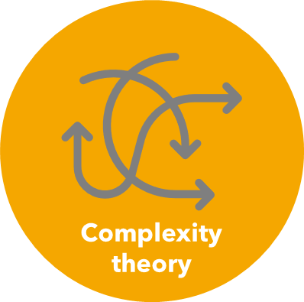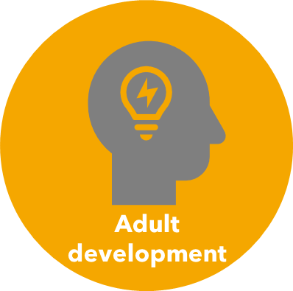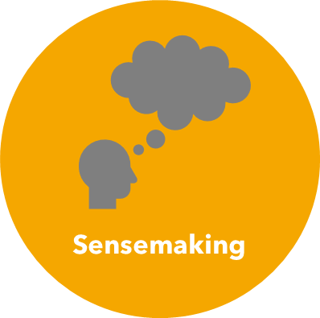

Aims and Objectives

Programme aims
The aim of the programme is to enhance the sense-making capacity of school leaders to better handle the challenging problems they face.
This includes:
- Vertical development - an increased sense-awareness of their own sense-making capacity
- Horizontal Development - a quantitative shift in their stage of Adult Ego Development (AED).

Programme objectives
The programme will provide the stimuli for development and reflection and the opportunities to practice and work on participants’ approach to sense-making.
This includes:
- Supporting changes in knowledge including declarative knowledge, procedural knowledge, and self-regulatory knowledge.

- Supporting changes in behaviour. Behaviour, and the outcome of changes in behaviour, can provide experiences that might challenge participants’ previously held way of working. Such an approach will include raising the motivation to act; raising self-efficacy of participants to act; helping individuals to record their actions and track their progress.

- Directly providing experiences that are purposively designed to challenge sense-making and expose participants to:
  - alternative perspectives.
  - group/collaborative sense-making.
  - the complexity inherent within problems.

Components of the programme

Fundamental to sensemaking are the mental models that give meaning to experience. The programme will therefore maximise the connection between learning about different types of knowledge (declarative, procedural and contextual) alongside exposure to personally salient experiences. To achieve this, the programme is structured as a cyclical process which includes three elements:
- Group Development Sessions (GDS)
- Individualised Development Sessions (IDS)
- Individual tasks and journaling.
The cyclical nature of the programme allows participants to reflect and act upon the previous session, leading to a developmental process.
To facilitate ego growth, the following characteristics are integrated into each element:
- A stimulus which is personally salient, emotionally engaging, and interpersonal in nature.
- Interactions with other individuals or challenging environments to stimulate a disequilibrium in schemas.
- Time for reflection and sensemaking.
- Group discussions which provide connections to other leaders through collaborative sensemaking balanced with opportunities to act autonomously.

Group Development Sessions (GDS)
The stimulus for GDS takes three forms:
- Facilitator input
- Case studies
- Reflections on individual work
The purpose of the case study and individual work is to provide a disequilibrating experience by exposing participants to a complex problem that is personally salient, emotionally engaging, and interpersonal in nature. Participants will be encouraged to work together and support each other in making sense of this stimulus, using collaborative reasoning to find resolutions. To facilitate structured discussion, Dialogic Inquiry and Dialectical Thinking tools will be employed.

Individual Development Sessions
The GDS becomes the stimulus for the IDS. This informs the design of an ‘experiment’ which will form the basis for reflective work prior to the next GDS. An ‘experiment’ is a set of concrete actions and ways of working which the participant will try out in their work setting.
The sequence of activities for GDS and IDS is as follows:
Experiment
GDS
IDS
IDS
GDS

Explainers
The introduction and exemplification of relevant declarative knowledge will be delivered through recorded content. This method ensures consistency and accuracy of instruction across multiple programmes and means that variations in local expertise are mitigated against.
There is the need for taught content to be weighted towards the start of the programme, but these may be revisited throughout the programme. Additional ‘refresher’ videos and extended content will also be made available, accessible by participants at key points throughout the programme or ‘just-in-time’ for class assignments.

Overview of the Programme

The full programme is designed to last approximately 3-6 months.
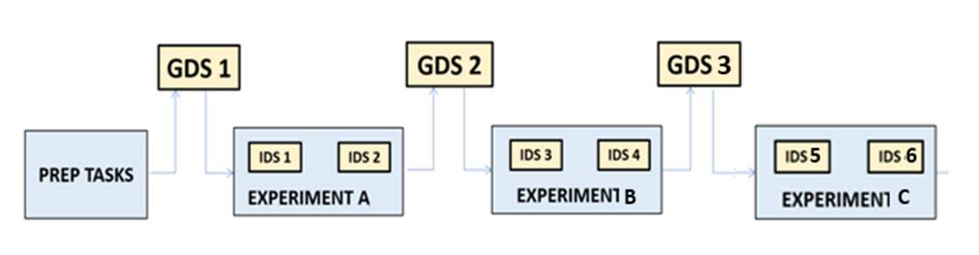

Preparation
Participants will prepare for the programme by watching a series of Explainer videos which introduce the programme and provide an overview of the key theoretical concepts.

Cycle 1 – Exploring Wicked Problems
The first cycle will
- Revise key theoretical ideas from the explainer videos
- Increase familiarity of wicked problems
- Increase their familiarity with how wicked problems appear in their setting

Group Development Session 1

In the first Group Development Session, participants will recap the content of the Explainer videos, be introduced to the idea of wicked problems, explore two Case Studies, and be introduced to the first Experiment.

Experiment A
Participants will attend:
- Individual Development Session 1 with their Individual Facilitator to plan the Experiment. They will then carry out the Experiment A
- Attend a further Individual Development Session (Session 2) to reflect on their findings.

Cycle 2 – Defining Wicked Problems
The second cycle will
- Revise key theoretical ideas from the explainer videos
- Help you to define a wicked problem in your context
- Explore how different individuals can see the same problem in different ways

Group Development Session 2
In the second Group Development Session, participants will explore two more Case Studies, and be introduced to Experiment B.

Experiment B
Participants will attend an Individual Development Session with their Individual Facilitator to plan the Experiment. They will then carry out the Experiment and attend a further Individual Development Session to reflect on their findings.

Cycle 2 – Defining Wicked Problems
The second cycle will
- Help you to reflect on your learning thus far
- Explore how we can work with others to comprehend complex problems
- Begin to employ approaches to working through solutions for complex problems

Group Development Session 3
In the third and final Group Development Session, participants will consolidate their learning through the Experiment, consider a final Case Study and a final experiment.

Experiment C
Participants will attend an Individual Development Session with their Individual Facilitator to plan the Experiment. They will then carry out the Experiment and attend a further Individual Development Session to reflect on their findings

Roles and responsibilities

Programme Coach
The role of the Programme Coach is to meet with the Programme Leader prior to each phase of the programme to support preparation and support development in the Programme Leader’s facilitation.
Time commitment: 2-3 hours

Programme Facilitator
The role of the Programme Lead is to facilitate the GDSs, co-ordinate Individual Facilitators, and to provide feedback to participants through the final reflective piece and one-to-one meeting.
Time commitment: 8-12 hours (depending on cohort size)

Individual Facilitator
The role of the Individual Facilitator is to support participants in reflection and action planning throughout the programme.
Time commitment: 2-3 hours

Group Development Sessions

GDS 1: Programme introduction

Aims:
- To check understanding and develop a critical awareness of the key theoretical constructs
- To provide a programme overview
- To engage participants in two case studies to help them became familiar with exploring the school’s wicked problems with others
- To introduce the role of the Individual Facilitator
- To frame Experiment A.

GDS 2: Programme mid-point

Aims:
- To consolidate learning from the Experiment
- To engage participants in two case studies centred around defining wicked problems
- To further reinforce key theoretical constructs
- To frame Experiment B.

GDS 3: Programme conclusion
Aims:
- To consolidate learning from the Experiments
- To engage participants in one case study centred around finding solutions for wicked problems
- To further reinforce key theoretical constructs
- To frame Experiment C.

Individual Development Sessions
In all IDS sessions, it is vital that you and your coach work through the IDS Support Sheet. This worksheet is available on the website. The focus of the IDS will require both the facilitator /and the participant to
- Be familiar with the content of the GDS before/after the IDS
- Be familiar with the experiment

IDS1/3/5
The purpose of IDS1/3/5 is to prepare for the Experiment. This will include:
- Participant explains what complex problems are to Individual Facilitator
- Individual Facilitator and participant check understanding of the Ladder of Inference
- Planning for the Experiment.

IDS2/4/6
The purpose of IDS2 is to reflect on the outcome of the Experiment. The Personal Facilitator will enquire about:
- How did the participant go about the experiment?
- What were their findings?
- What reflections will the participant take forward to the Group Development Session?

Participant Reflections

Participants will be encouraged to reflect individually by keeping notes or a journal of their reflections throughout the programme.

Journaling
Journaling is likely to be a continuous process, prompted by the GDS, IDS and other events and reading. Writing up personal experiences may be prompted following particular events.
Journaling does not need to be very structured. However, participants may want to reflect on the following:
- What can theory tell us about how school leaders make sense of their roles?
- How is my view of schools and the job of school leaders changing?
- In what ways do others view the school I work in differently to me?
- Why do others perceive of the challenges we face as a school differently to me?
- How have my views been challenged by others (either through GDS/IDS discussions or through the experiment)?
- How is my understanding of the problems we are trying to solve changing?
- How comfortable am I with ambiguity, uncertainty and complexity?
- What does it mean to improve a school?

Explainers
Explainer videos introduce facilitators and participants to the key theoretical constructs required for the programme. Please do ensure participants watch these in advance.

Experiments

An experiment is an opportunity to test a hypothesis about the school in which the participant works. Each experiment will begin by participants framing a hypothesis. They will test this hypothesis through interaction with others in their setting.
In the pilot programme, participants carry out one of the following Experiments. This is the choice of the Programme Facilitator.

Experiment A: Exploring your school’s complex problems with others
Participants will be asked to do the following:
- Create a hypothesis about what people in your school would identify as the key complex problems in your context.
- Test this hypothesis by asking colleagues in various positions in your school to identify the most significant complex problems faced by the school.
- Reflect on the extent to which the responses provided confirm or diverge from your hypothesis.

Experiment B: Defining a complex problem
Participants will be asked to do the following:
- Choose a complex problem which is significant within your context.
- Create a hypothesis about the origins and salient features of this problem (a ‘problem definition’).
- Test this hypothesis by discussing with 2-3 colleagues in various positions in your school to uncover alternative perspectives and assumptions.
- Produce a refined version of your problem definition.

Experiment C: Exploring solutions
Participants will be asked to do the following:
- Create a hypothesis about what the possible solutions might be to your selected complex problem.
- Convene a group of colleagues to discuss the problem and suggest possible solutions.
- Consider how the solutions proposed and preferred take account of the ‘complexness’ of the problem.

Programme Evaluation
The programme will be evaluated through the use of the voluntary assessment framework. Please look on the website for further information.

Delivering a MSSL programme

Step 1: Meet with your Programme Coach to plan implementation
Step 2: Recruit Individual Facilitators and brief them about their role in the programme
Step 3: Recruit participants
Step 4: Provide participants with the programme resources and ask them to watch the Explainer videos
Step 5: Facilitate Group Development Session 1
Step 6: Ask participants to organise Individual Development Sessions and carry out the Experiment
Step 7: Facilitate Group Development Session 2
Step 8: Ask participants to organise Individual Development Sessions and carry out the Experiment
Step 9: Facilitate Group Development Session 3
Step 8: Ask participants to organise Individual Development Sessions and carry out the Experiment

